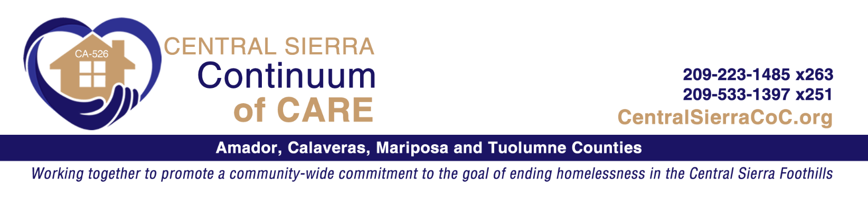
ESG Committee | This committee works with the Collaborative Applicant to provide guidance in preparing the application and updates to assist the CSCoC in application and grant processes. This committee also meets with new applicants to mentor them on project guidelines and accessing eSNAPS.
Organization | Name | Phone | Email | Membership
Alliance for Community Transformations | Lisa Parker  Ron Hull | 209-966-7770 | lisa@alliance4you.org  ron@alliance4you.org | Member
ATCAA | Denise Cloward  Sandra Sturzenacker | 209-223-1485 x263  209-223-1485 x251 | dcloward@atcaa.org  ssturzenacker@atcaa.org | Board
 | Carolyn Wice | 209-742-0860 | cwice@mariposthsc.org

